Request & Response Cycle

1. Request

<html>

    <body>

    <h1>Request</h1>

    <p id="p"></p>

    <script>

        // Instantiating new XMLHttpRequest() method

let xhr = new XMLHttpRequest();

// open() method to pass request

// type, url and async true/false

xhr.open('GET',

    'https://jsonplaceholder.typicode.com/users/2', true);

// onload function to get data

xhr.onload = function () {

    if (this.status === 200) {

        console.log(JSON.parse(this.responseText));

    }

}

// Send function to send data

xhr.send()

    </script>

    </body>

</html>

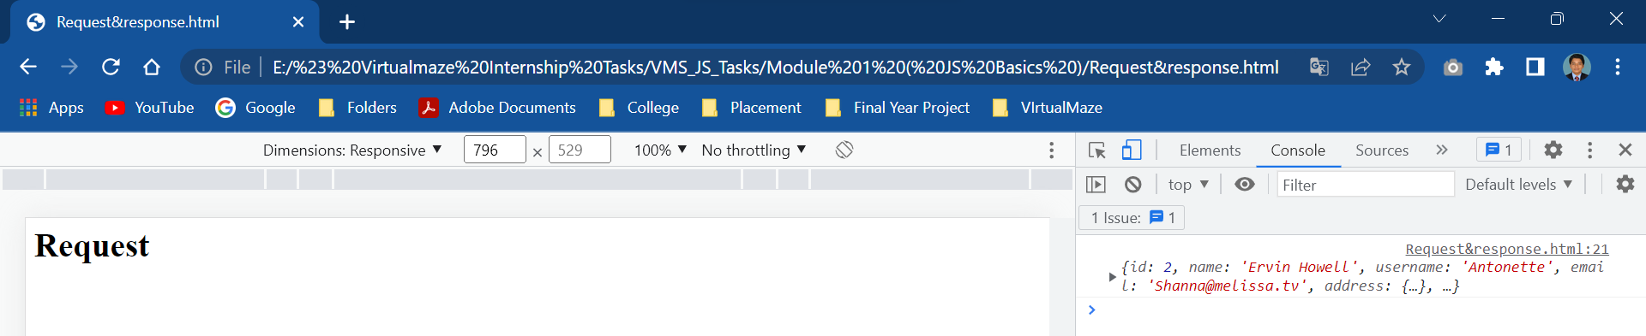

1. Response

  <html>

    <body>

    <h1>Response</h1>

    <p id="p"></p>

    <script>

// Instantiating new XMLHttpRequest()

let xhr = new XMLHttpRequest();

// open() method to pass request

// type, url and async true/false

xhr.open('POST',

    'http://dummy.restapiexample.com/api/v1/create', true);

// Setting content-type

xhr.getResponseHeader('Content-type', 'application/json');

// Perform the following when the response is ready

xhr.onload = function () {

    if (this.status === 200) {

        console.log(this.responseText)

    }

    else {

        console.log("Some error occurred")

    }

}

// Send the request as an object obj

obj = `{"name":"Selmon Bhoi",

        "salary":"$10, 000", "age":"55"}`;

xhr.send(obj);

    </script>

    </body>

    </html>

